

Faculty of Information and Communication Technology

BsC Hons in Applied Computer Science

3rd year

PHM

TP 1

Submitted by:

LINGACHETTI Paavalen

Submitted to:

Mr BEEHARRY Shiam

Date: 03/02/2024

Task 1   
1. Install flutter

Download the zip from the futter website then extract it somewhere except in program files  
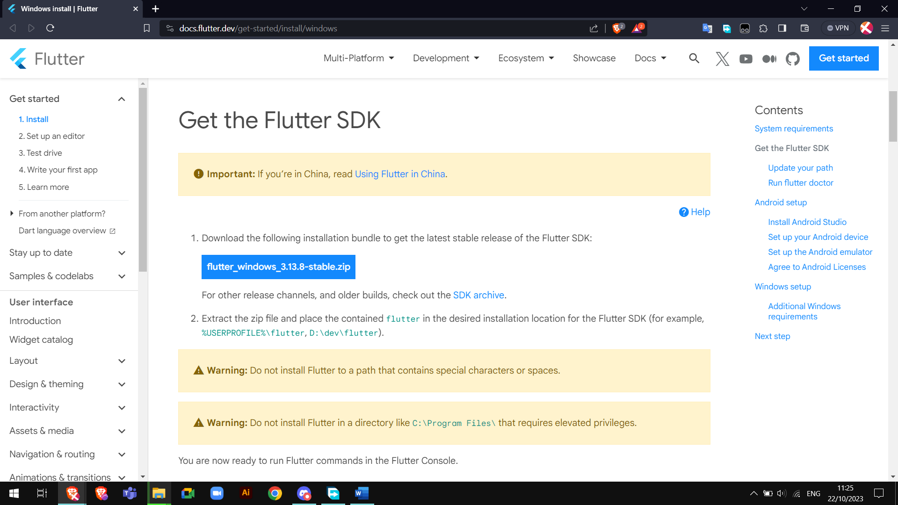

2 install Android Studio

Download the installer from the Android Studio website then run it

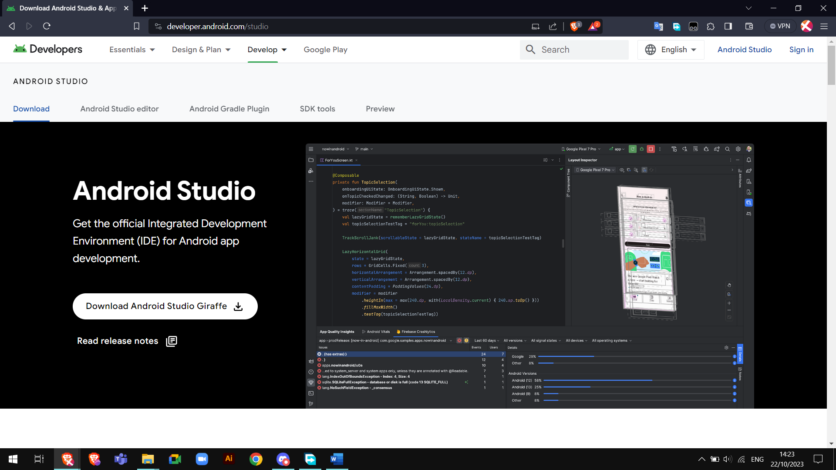

3. VS Code with Flutter Plugins

Install in flutter extension in vs code  
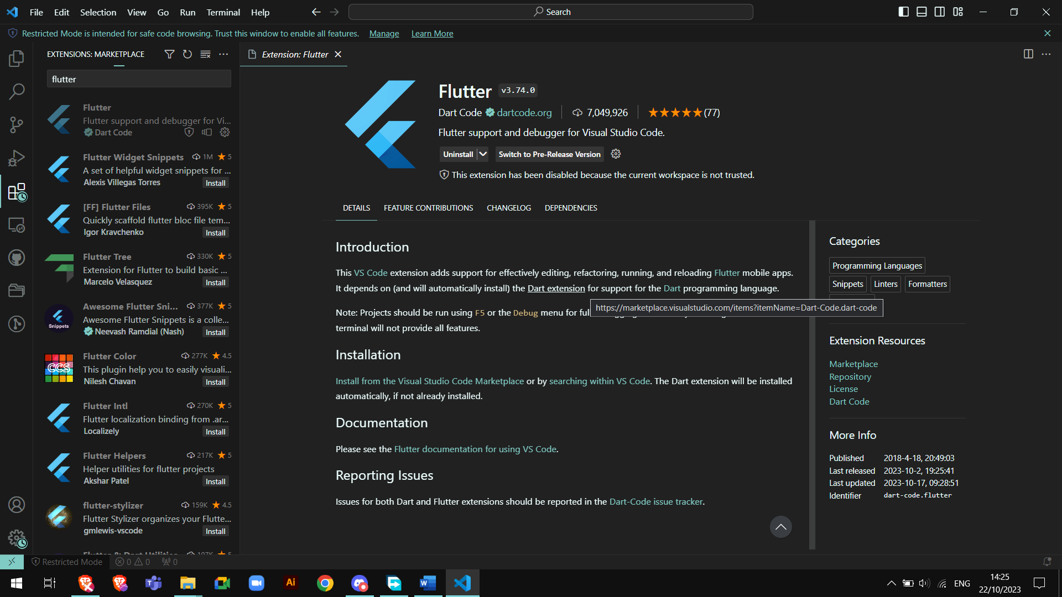

Run the command: flutter doctor -v  
 to find issues with the install  
  
Two issues found   
  
Issue 1 – Need to install Android SDK Platform Tools

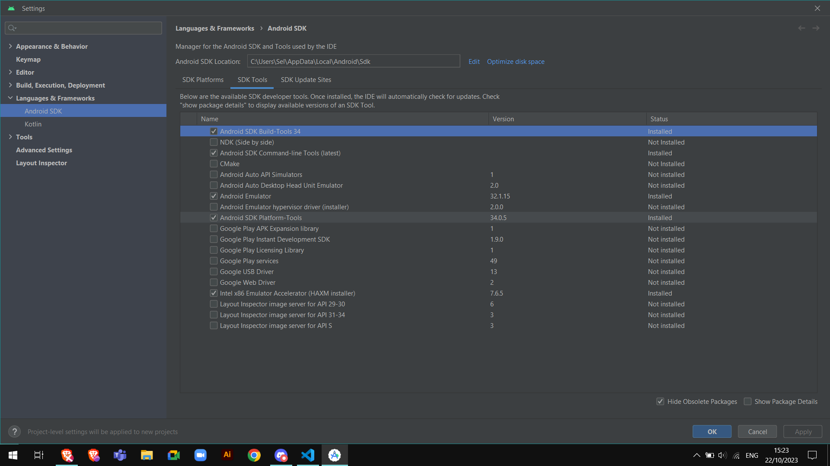

Issue 2 – need to accept the EULA  
  
run the command: flutter doctor --android-licenses  
then type y to accept the EULA

# Task 2

Create a wireframe for a Flutter App.

For this task we will use the online tool LucidChart.

We will do a wireframe for a messaging app.

Step 1 - First, we log in to LucidChart.

Step 2- click on template and type wireframe.

We choose the fourth template.  
  
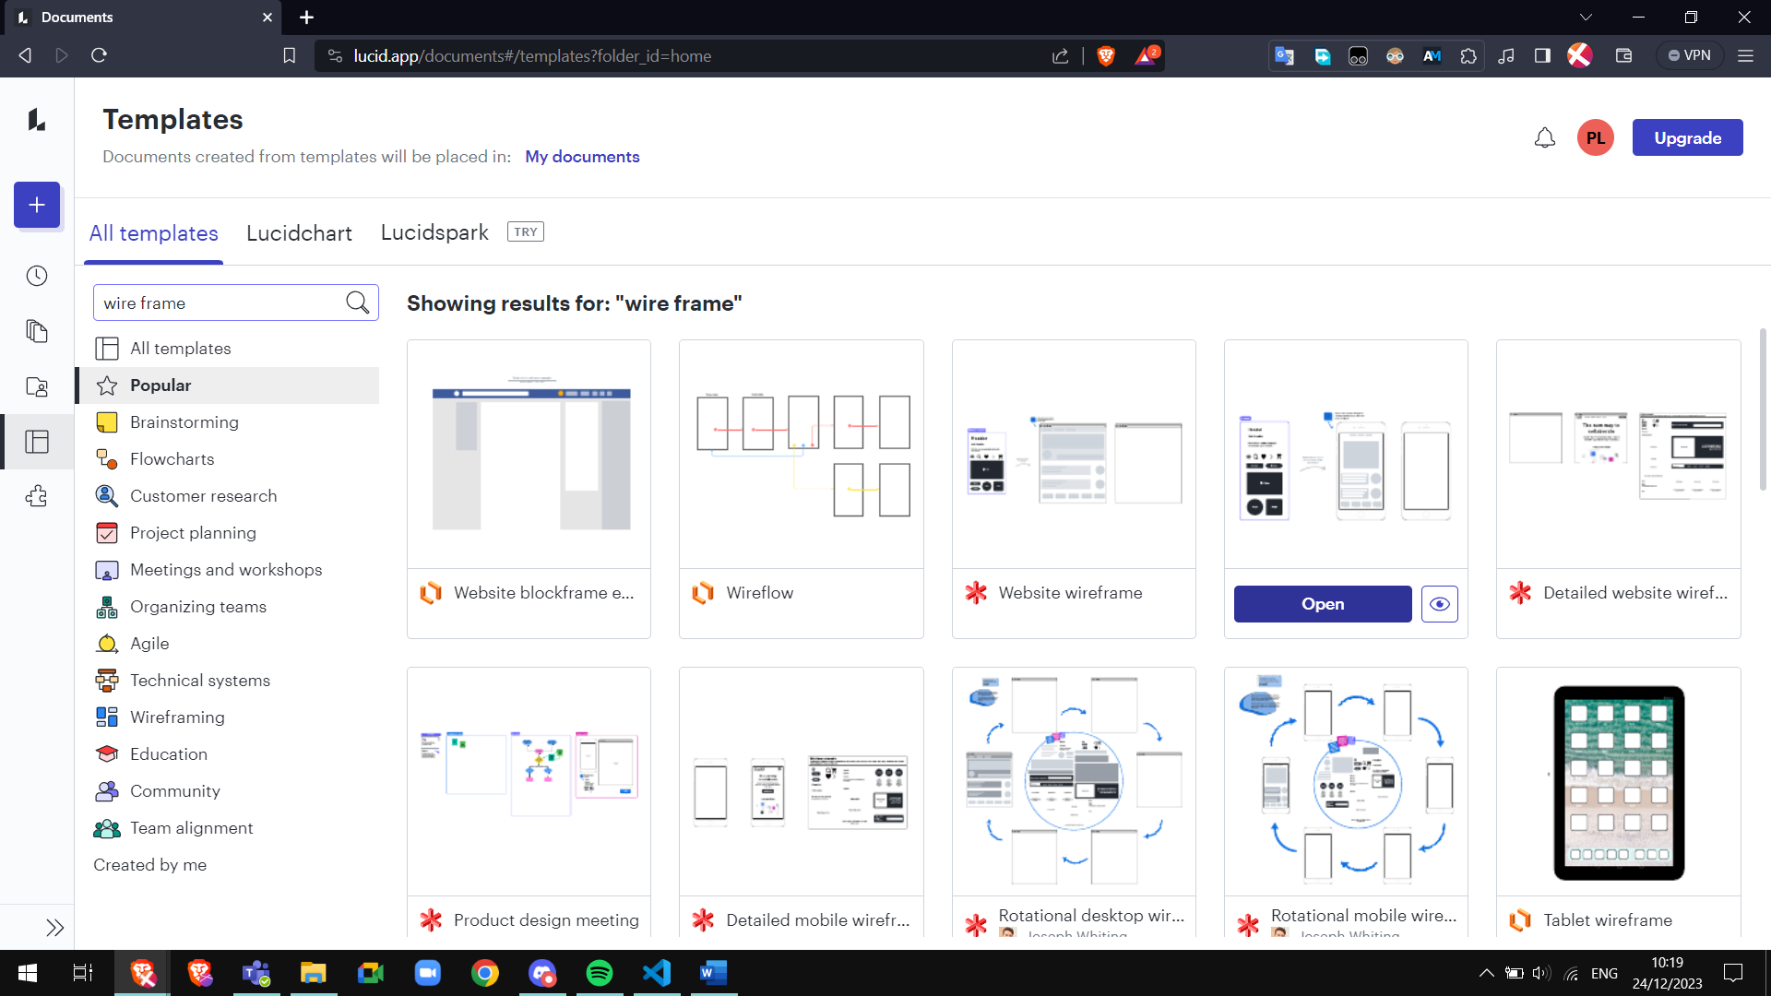

Step 3 conception  
  
By using the tools on the left side we can create the wireframe. It gives us access to variety if shapes, lines, colours, image and icons  
  
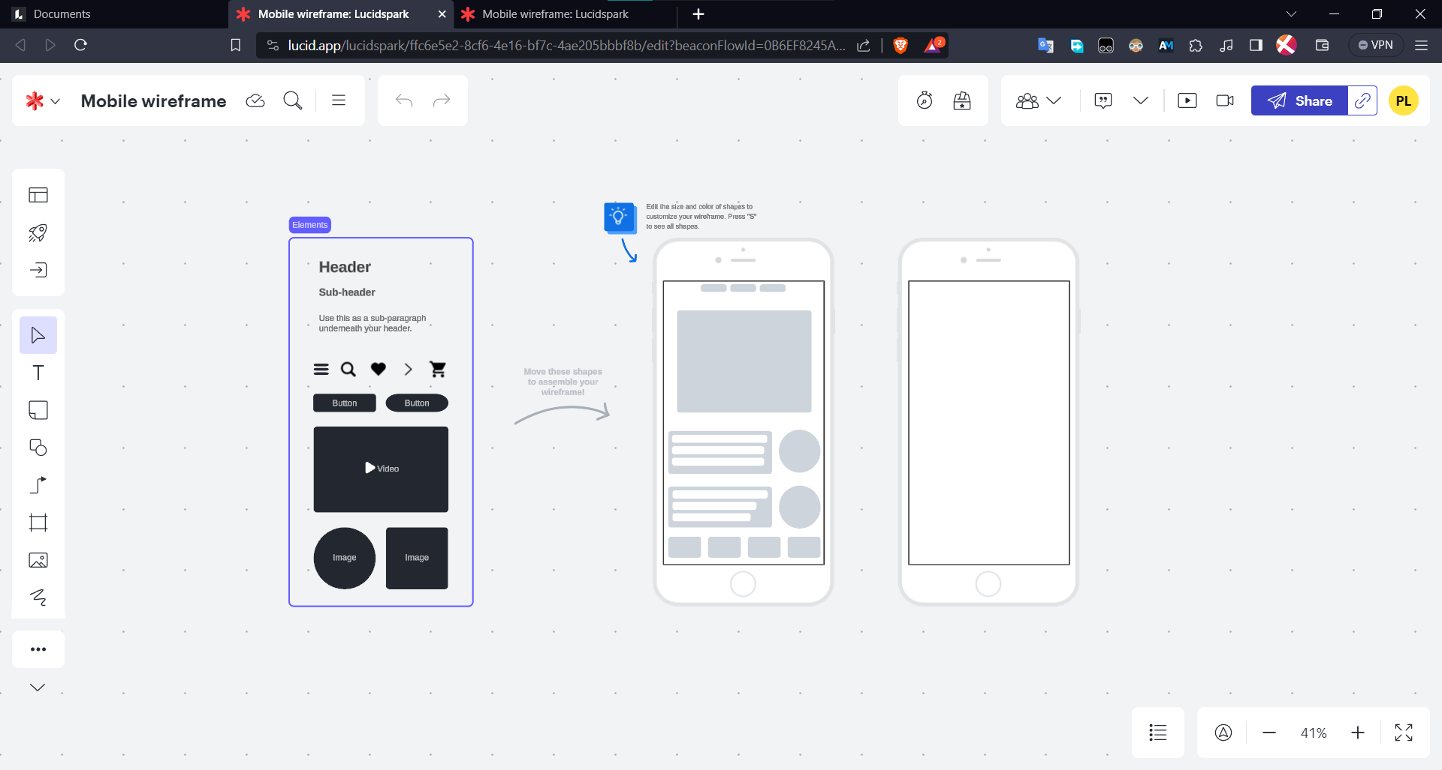

After removing the unnecessary items from the template, we used the tools to create this wireframe.

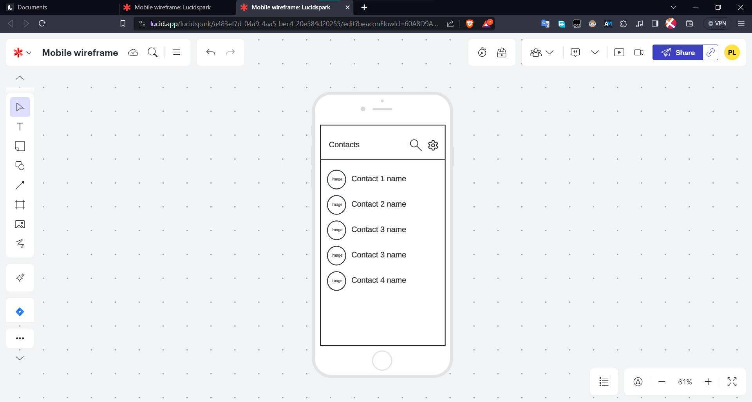

Here is the link for the wireframe (it contains the wireflow for task 3 too) -

[lucid.app](https://lucid.app/lucidspark/a483ef7d-04a9-4aa5-bec4-20e584d20255/edit?viewport_loc=1997%2C-849%2C2780%2C1372%2C0_0&invitationId=inv_b027d660-f01e-4e37-ae9d-0e2eb88d7f91)

# Task 3

Create a wireflow

We will be using the wireframe of task 2 and make it into a wireframe.

The wireflow show the steps to send a message.

Using the same method as task 2, created a simple linear wireflow.

Here is the link to the wireflow

[lucid.app](https://lucid.app/lucidspark/a483ef7d-04a9-4aa5-bec4-20e584d20255/edit?viewport_loc=1997%2C-849%2C2780%2C1372%2C0_0&invitationId=inv_b027d660-f01e-4e37-ae9d-0e2eb88d7f91)

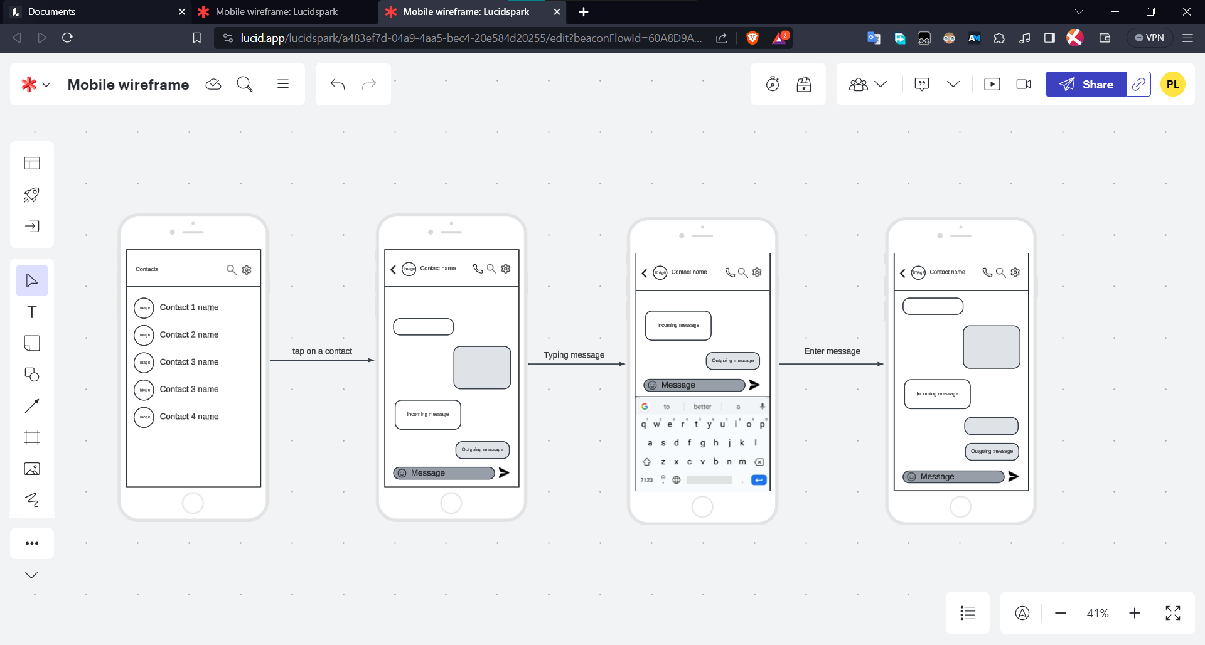

# Task 5

Create your first Flutter App in VSCode or Android Studio  
  
We followed this tutorial on [codelabs](https://codelabs.developers.google.com/codelabs/flutter-codelab-first#0)

In the command palette type flutter and select Flutter: New Project then application to create the project

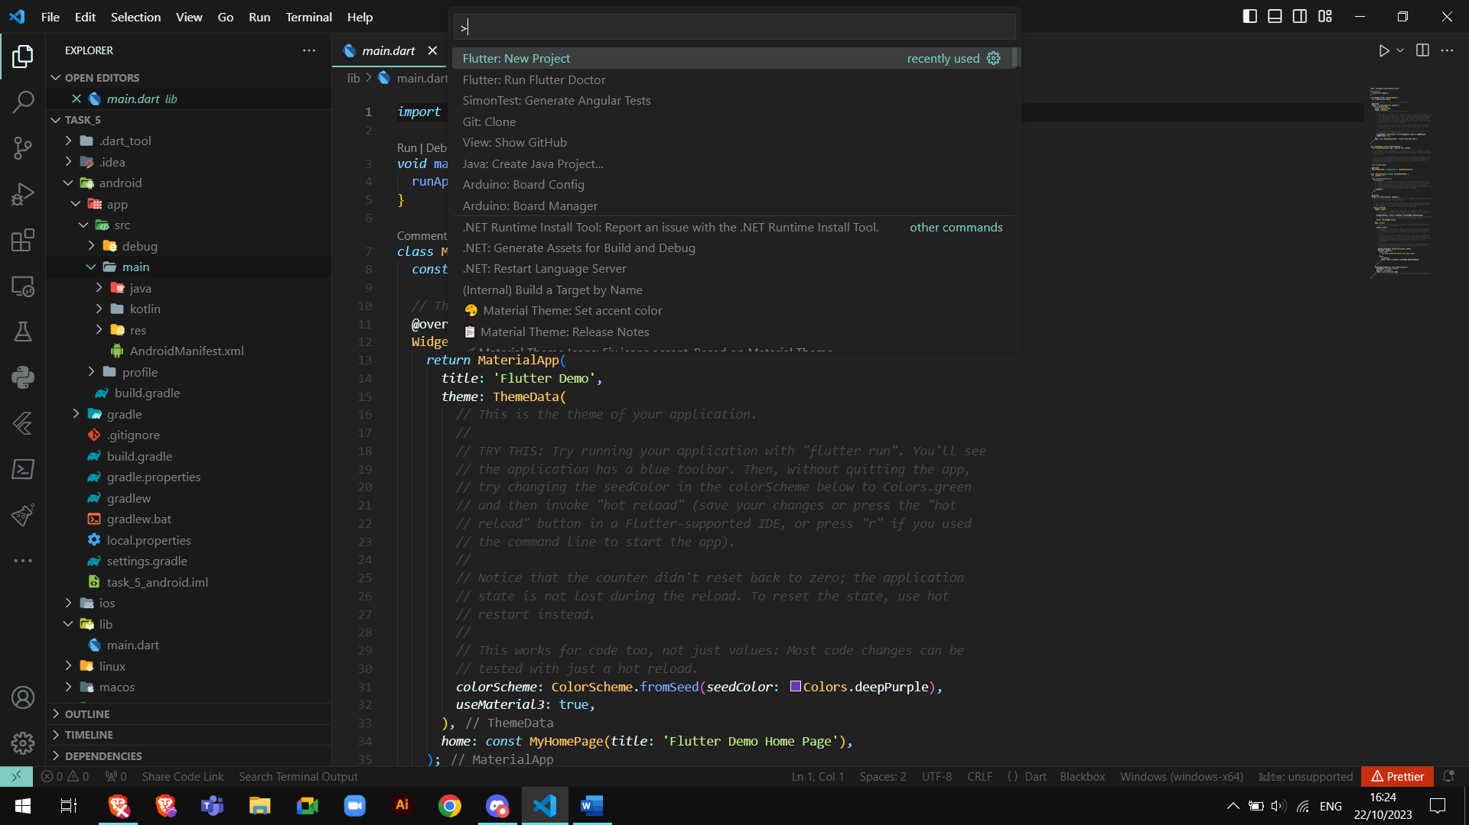

Replace the content of pubspec.yaml with the code from the tutorial  
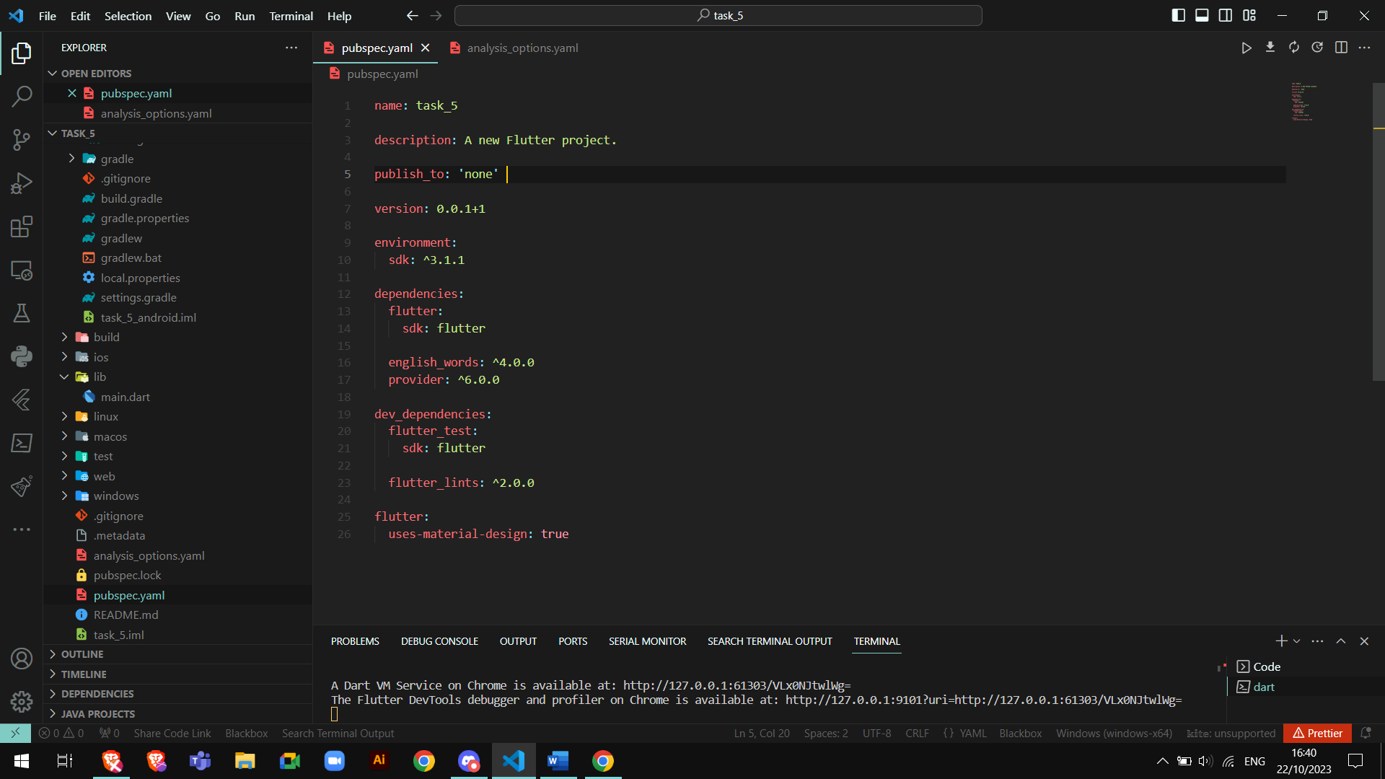

Same for the analysis_options.yaml file  
this code disables some features in order to keep the tutorial simple for beginners.

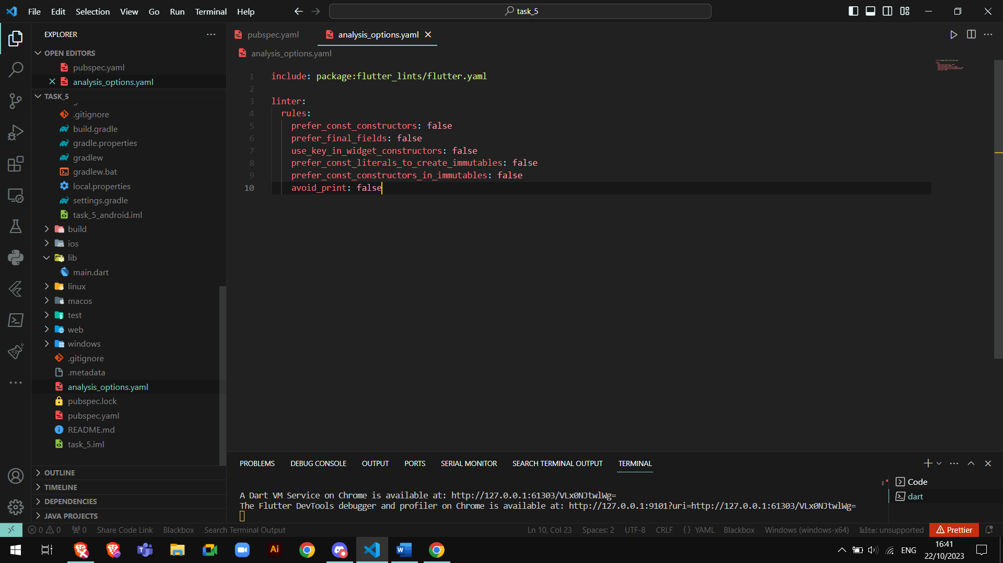

Same for the main.dart

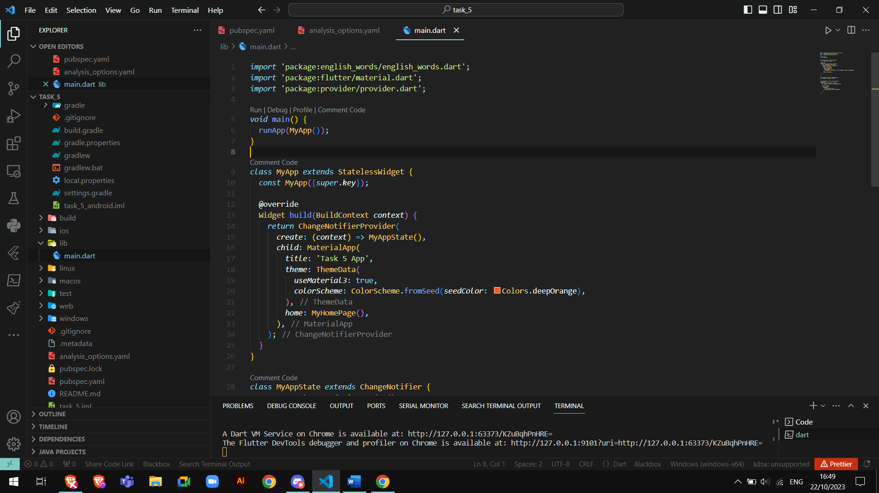

Run the application by entering flutter run in the terminal  
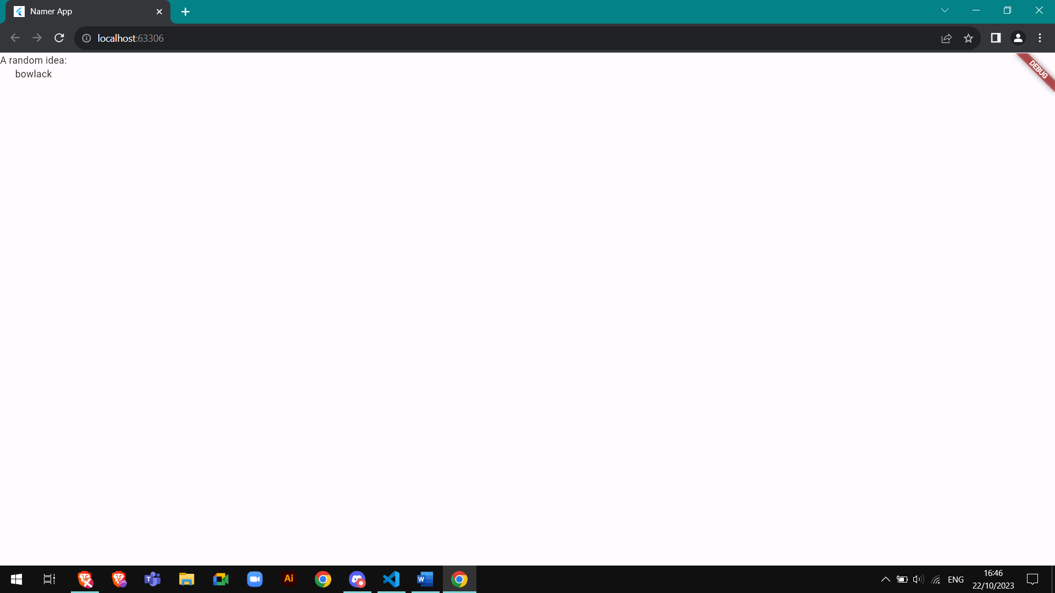

Add a button  
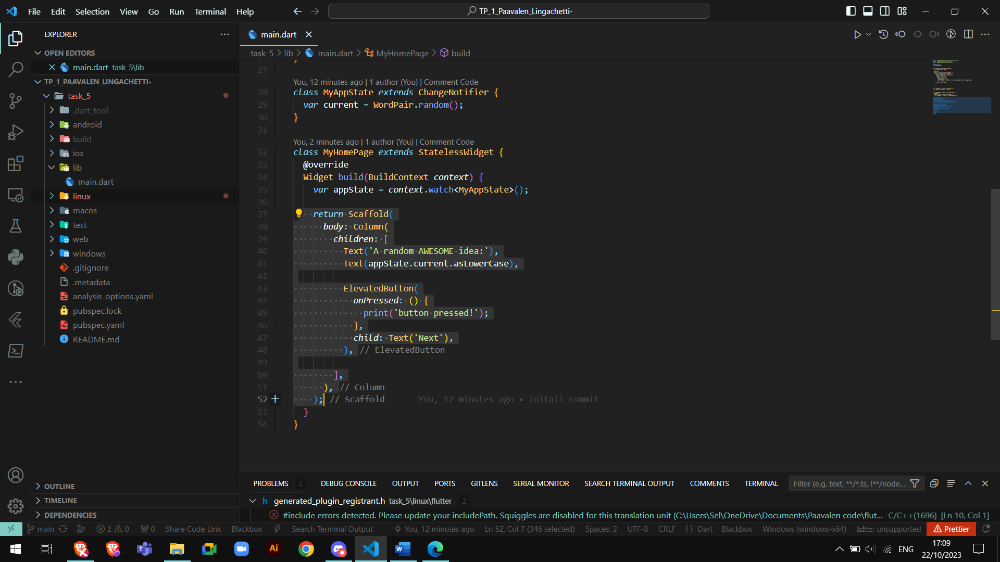

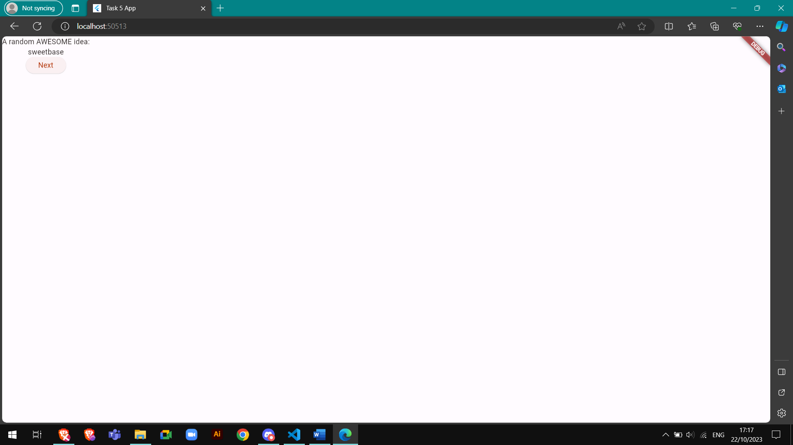

Add theme and style  
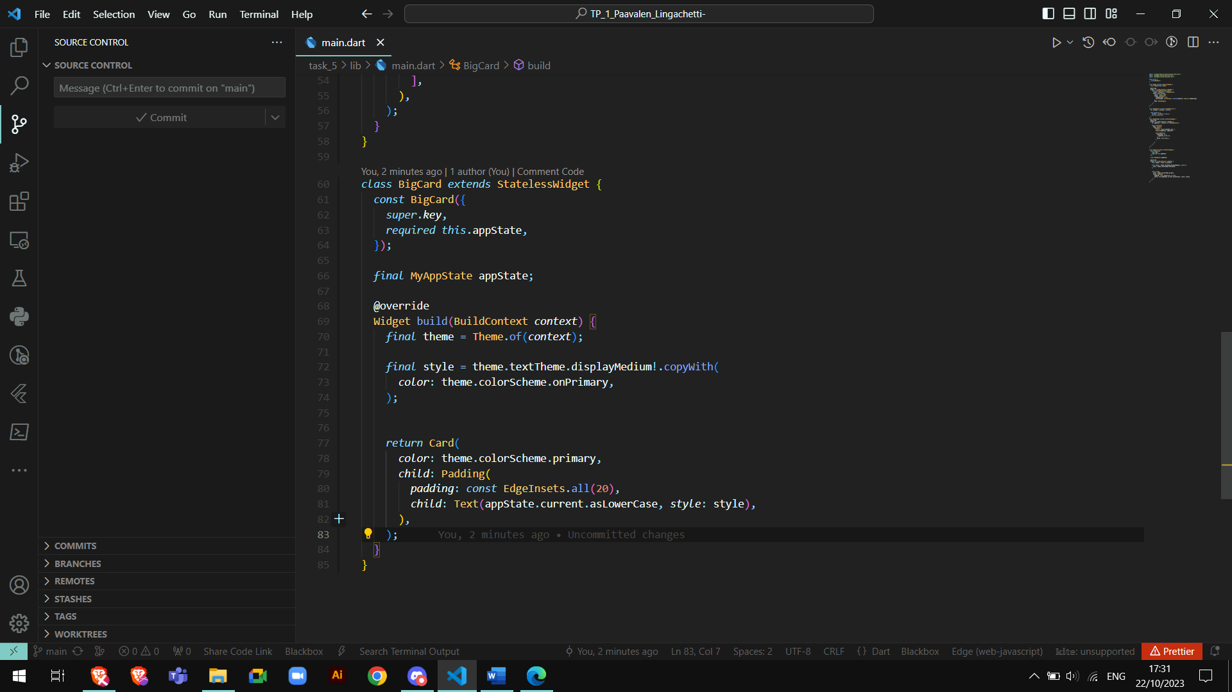

Centre the text and card  
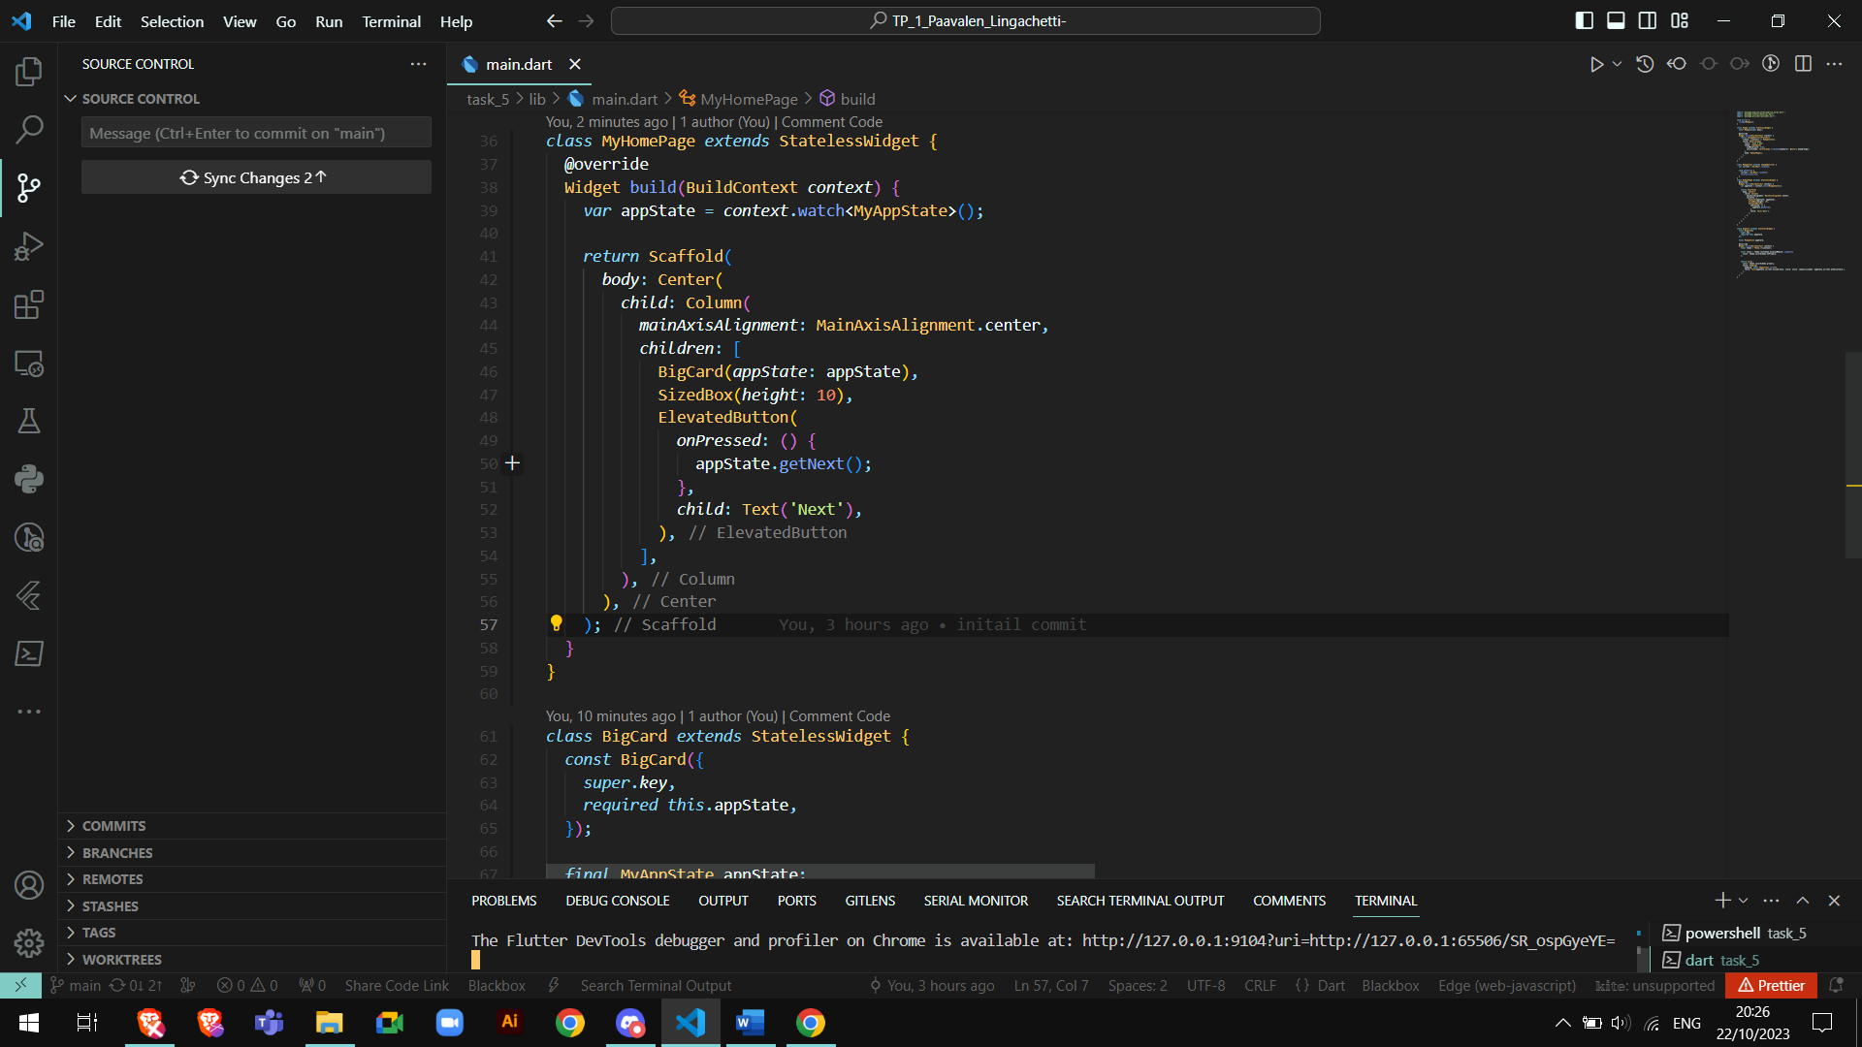

Result  
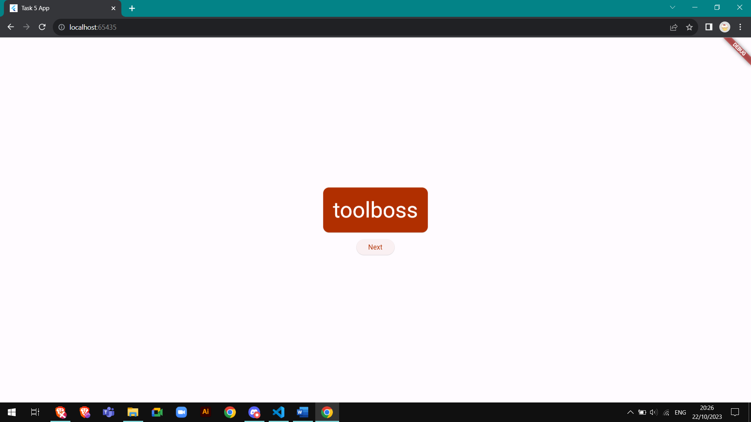

Here is the homepage with a navigation rail and a new favorite button  
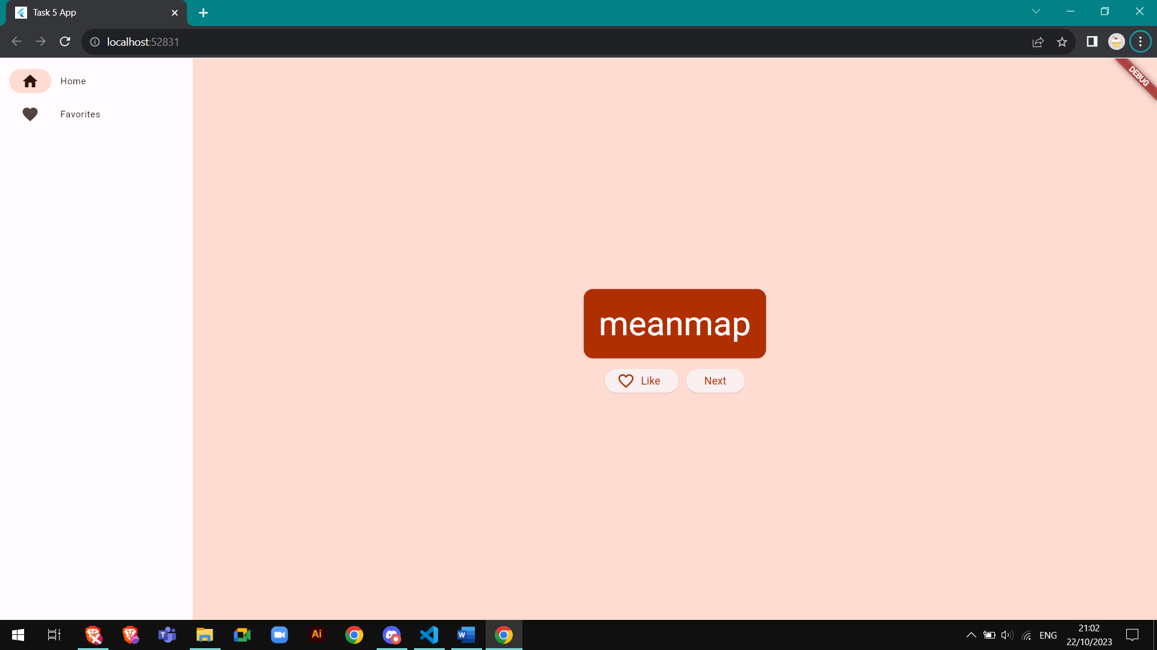

A place holder was added in the favorite page 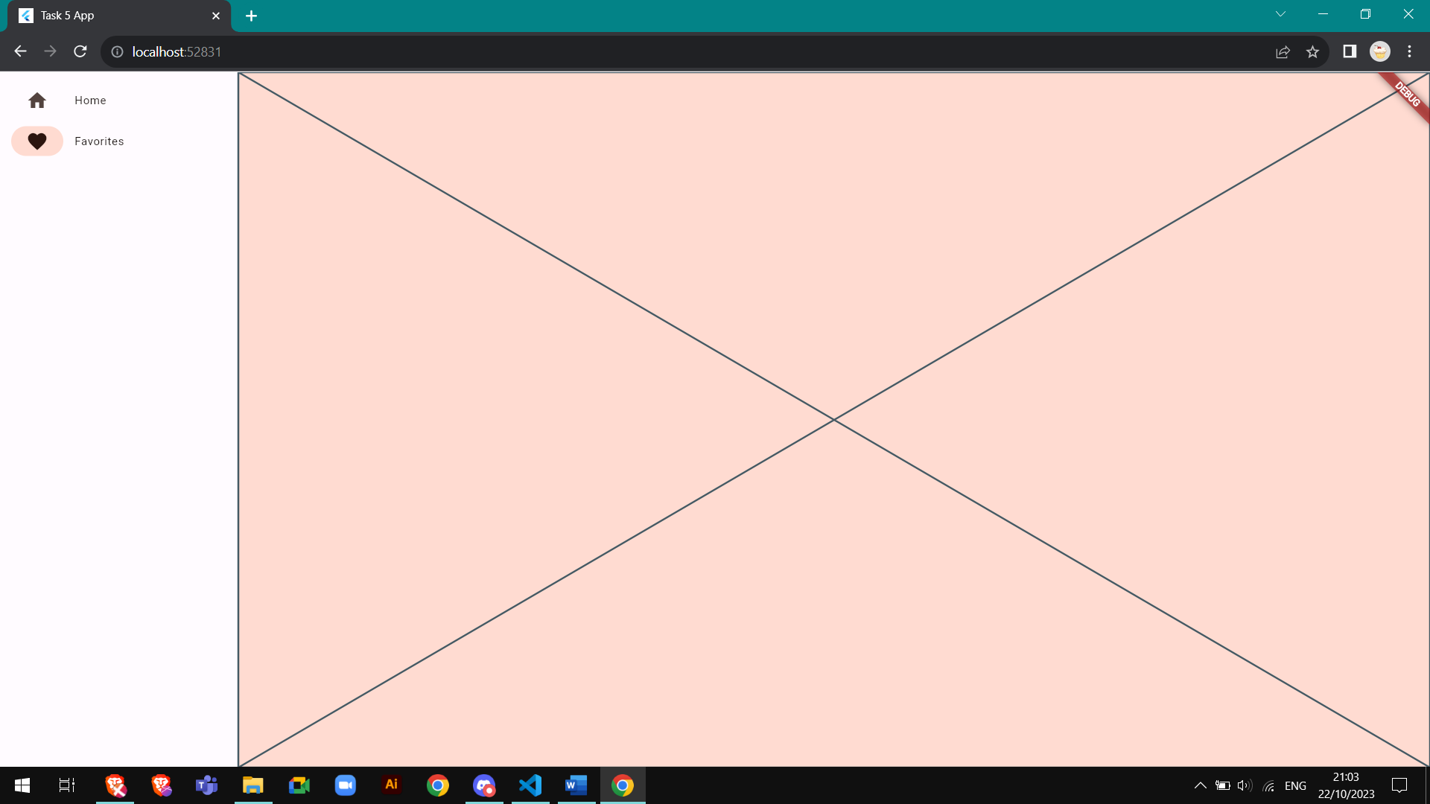

Here is the favorite page working

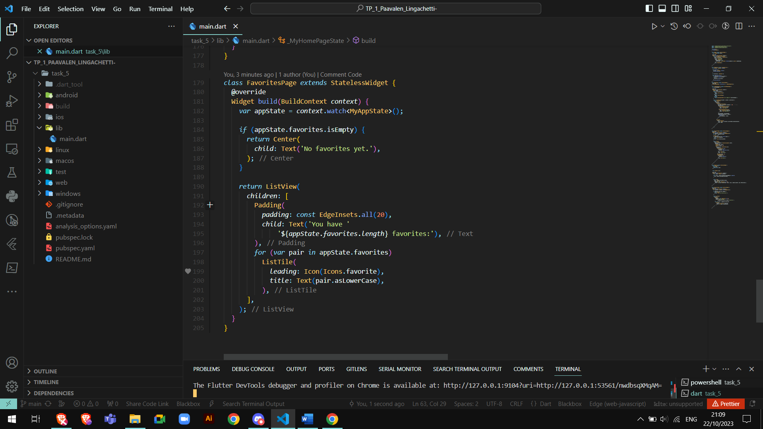  
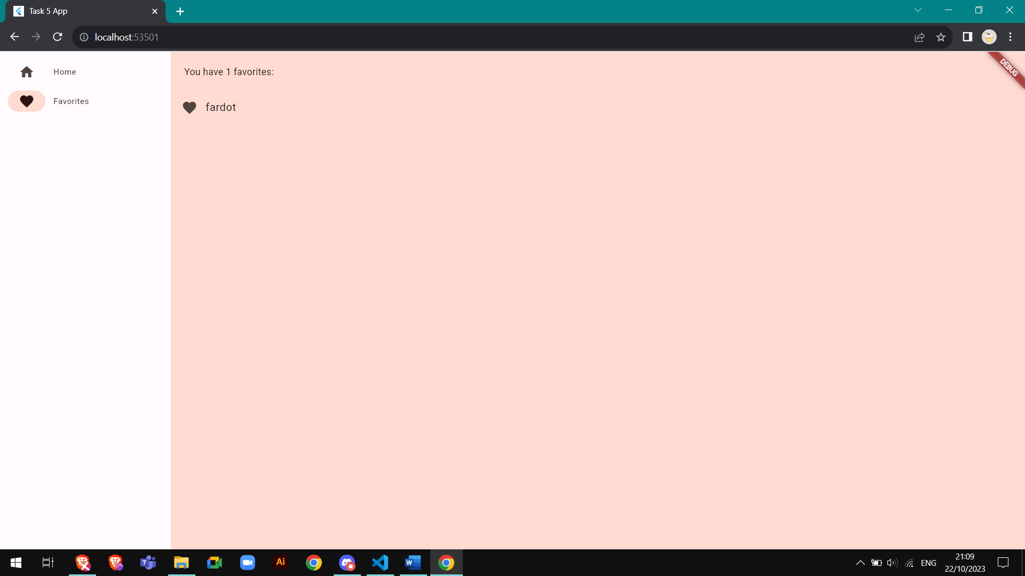

# Task 6

Visualizing dynamic color in your app

We followed this tutorial on [Codelab](https://codelabs.developers.google.com/visualize-dynamic-color#0).

Step 1 - Create an account.

Step 2 - open the [Figma Dynamic color Designlab file](https://goo.gle/visualize-dynamic-color-figma).

Step 3 - add the [Material Theme Builder](https://goo.gle/material-theme-builder-figma) Figma Plugin.

Drop in an image with **dynamic** select to get a colour scheme matching the image

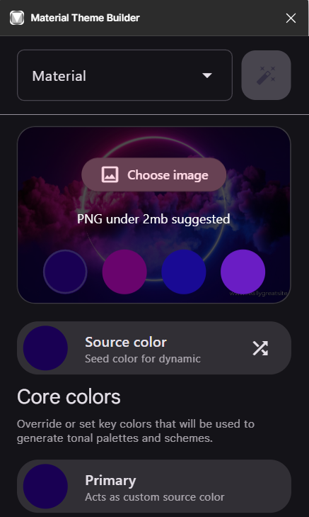

Task 7

Create your first App using MIT AppInventor

Step 1: create an account

Step 2: create a new project

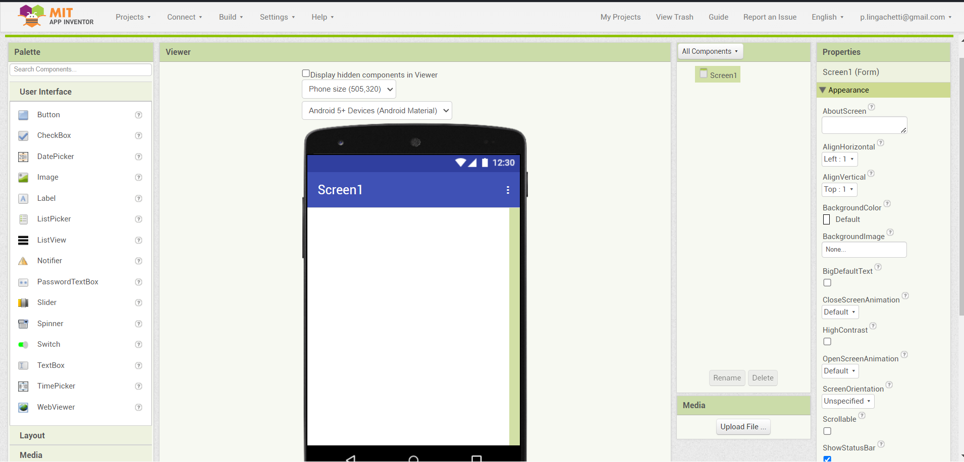

This small app will be a drawing app  
  
Place a canvas on the screen and set the height and width to “fill parent“ in order for the canvas to fit in the screen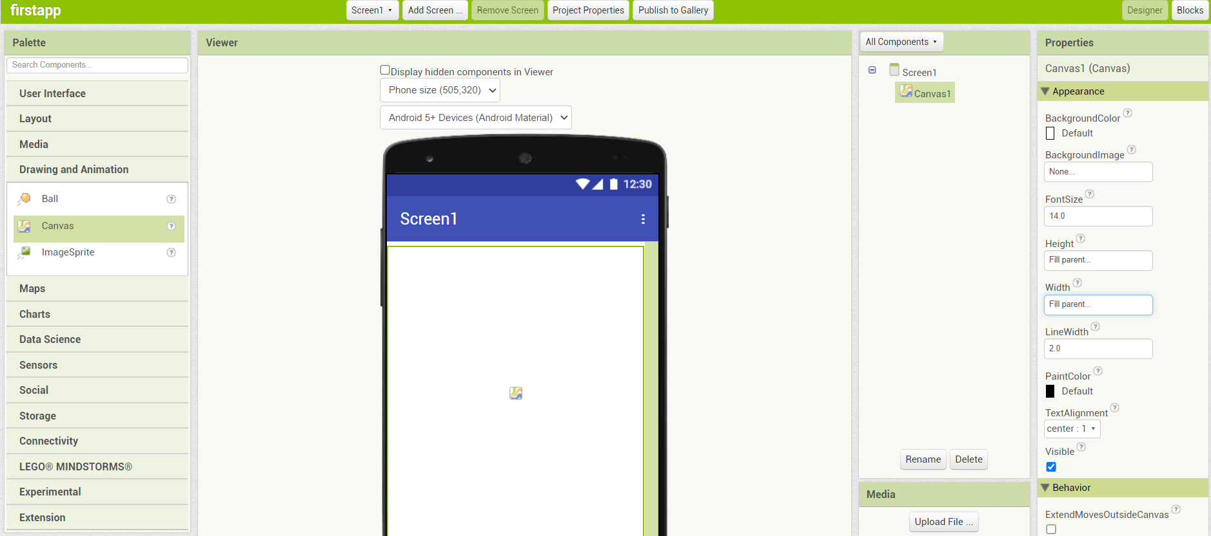

Add an accelerometer sensor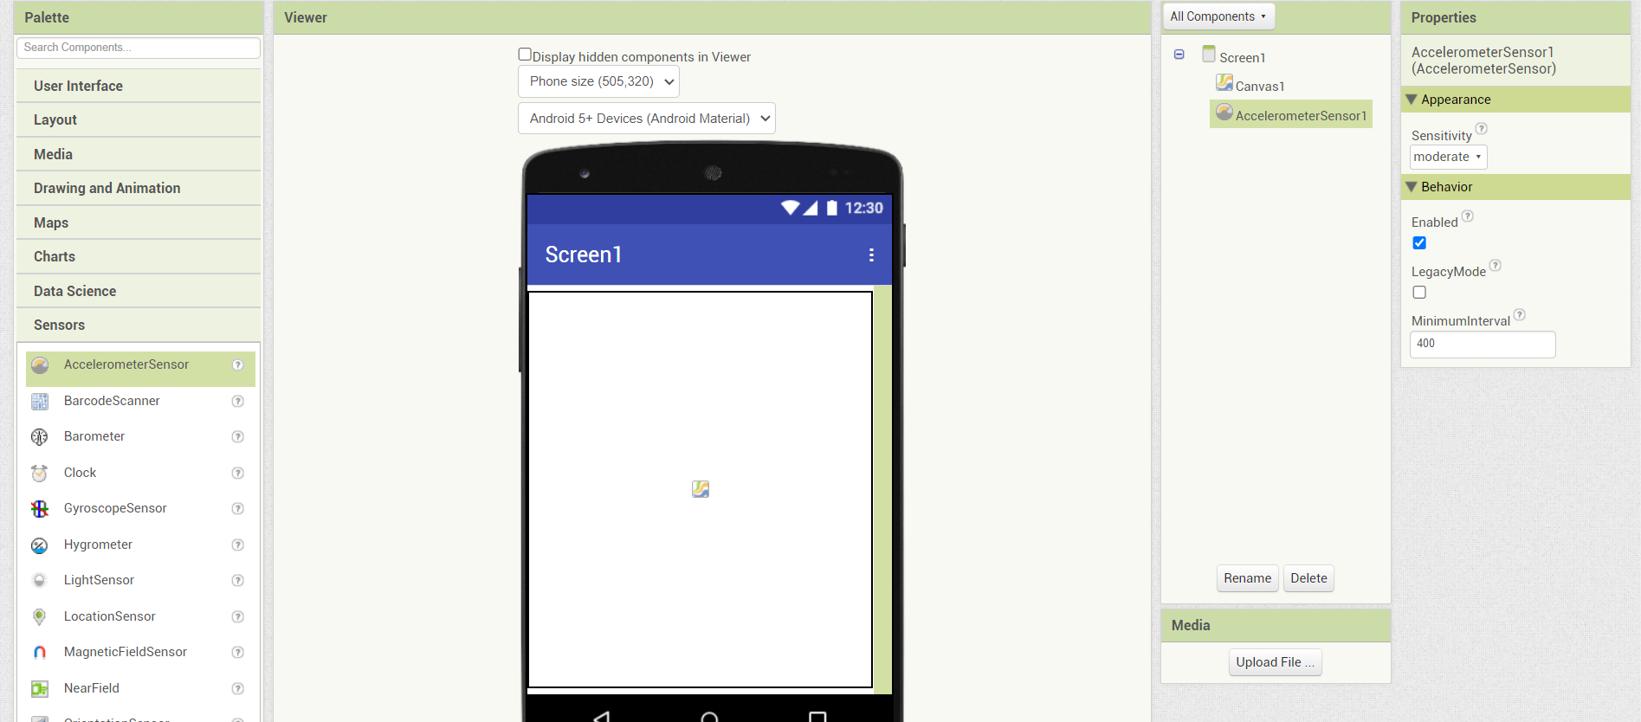

Now we will use the block tab to code the app

Click on block  
Select canvas and drag “when canvas1 .Dragged”

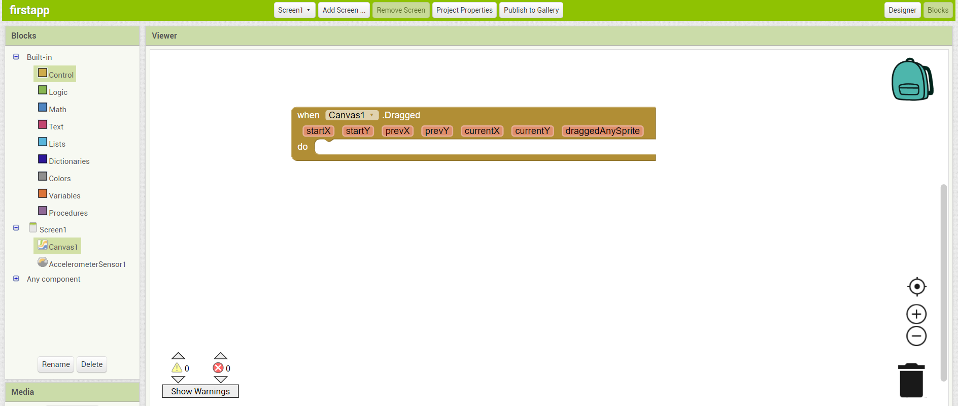

Add “call canvas1 .DrawLine” in startX

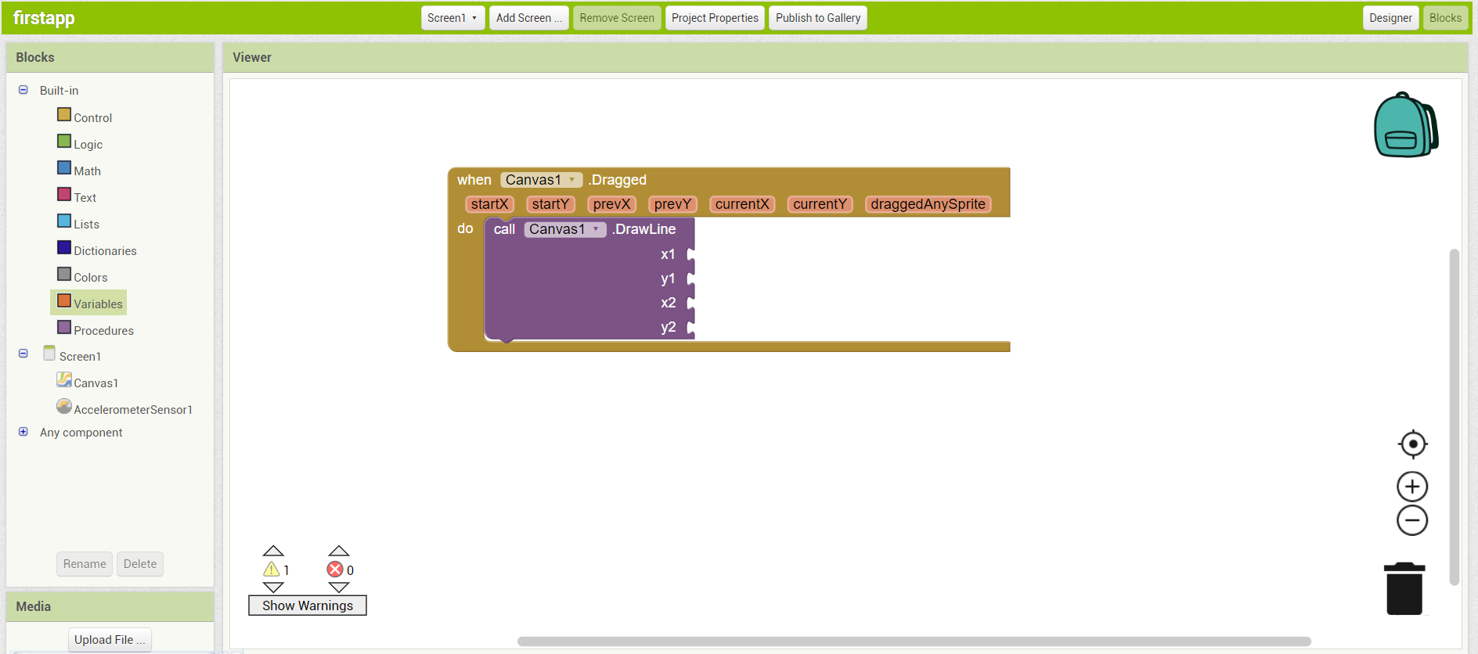

Add the variable get as shown in the screenshot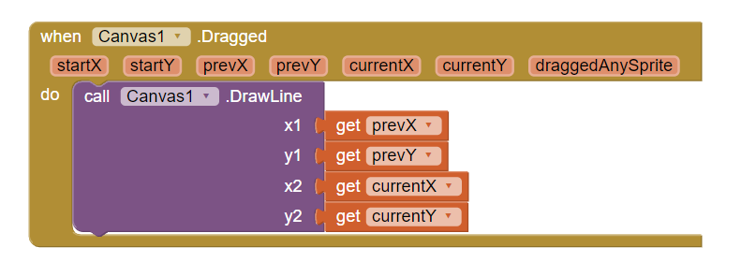

Now the program is coded

You have to build the project into a .APK and run it on your phone or emulator